Geeetech Prusa I3 pro W
User Manual

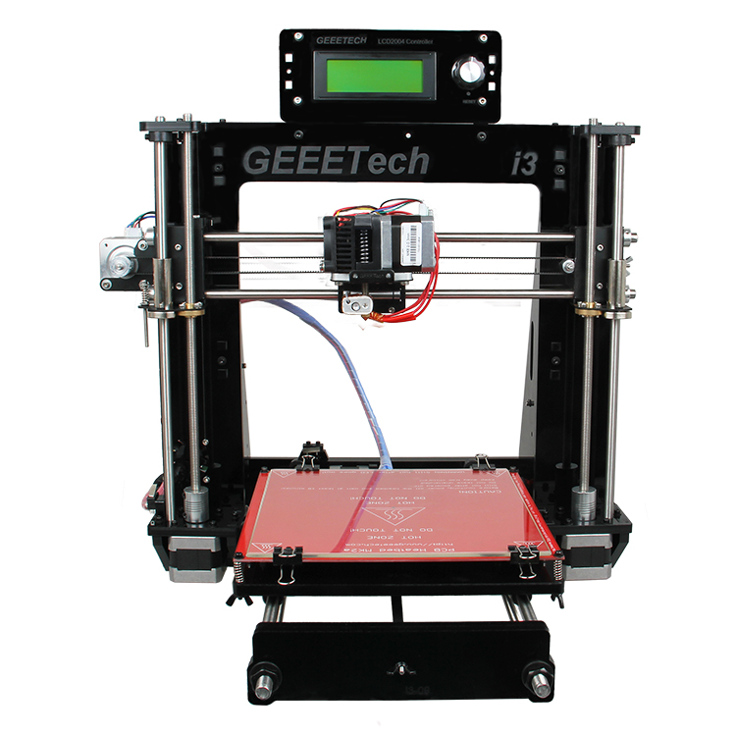

Safety Instructions
Building the printer will require a certain amount of physical dexterity, common sense and a thorough understanding of what you are doing. We have provided this detailed instruction to help you assemble it easily.
However ultimately we cannot be responsible for your health and safety whilst building or operating the printer, with that in mind be sure you are confident with what you are doing prior to commencing with building or buying. Read the entire manual to enable you to make an informed decision.
Building and operating involves electricity, so all necessary precautions should be taken and adhered to, the printer runs on 12V supplied by a certified power supply, so you shouldn’t ever have to get involved with anything over 12V but bear in mind there can still be high currents involved and even at 12V they shouldn’t be taken lightly.
High temperatures are involved with 3D Printing, the Extrusion nozzle of the hot end can run about 230°C, the heated bed runs 110°C and the molten plastic extruded will initially be at around 200°C, so special care and attention should be made when handling these parts of the printer during operation.
Check the power input of the power supply unit. You can choose either 110V or 220V according to the Power regulation in your country.
Tear off the yellow sticky note to check it. You can use a hard stick to reach into the power box and switch it. (依旧保留吗)
We wouldn’t recommend leaving your printer running unattended, or at least until you are confident to do so. We cannot be held responsible for any loss, damage, threat, hurt or other negligent result from either building or using the printer.

Content
1. Software Resources 1
1.1 Driver 1
1.2 Arduino IDE 2
1.3 EasyPrint 3D Installation and Configuration 2
2. Hotbed Leveling 5
2.1Homing 6
2.2 Coarse Tuning of distance between the nozzle and the hotbed 6
2.3 Fine Tuning 7
3. Print Settings 8
3.1 Quick mode 8
3.2 Custom mode 9
3.2.1 Create a new configuration/setting 9
3.2.2 Print settings 10
4. Begin Printing 20
4.1 Load a Model File 21
4.2 Print Setting 22
4.3 Slicing 22
4.4 Stand-alone print with SD Card 23
4.4.1 Save Job 23
4.4.2 Print 25
5. FAQ 26
5.1 How to upgrade firmware? 27
5.2 How to change the motor direction in firmware? 29
5.3 User manual of Repetier Host 30
5.4 Possible causes for motor’s non-action 30
5.5 Extruder does not work normally 30
5.6 The hotbed or extruder can not be heated 31
5.7 LCD error: MAX/MIN TEMP error 31
5.8 No information or displaying black square on LCD 31
5.9 Time.h/endstop hit or other abnormalities 31

1. Software Resources

1.1 Driver
Connect the printer to computer with USB cable, the motherboard driver installer will automatically appear. If not, you can download FT232RQ here, which is the driver of GT2560:
http://www.geeetech.com/wiki/index.php/Prusa_I3_X#Install_the_drivers
Download and install, you can find the corresponding serial port in the Windows "Device Manager":
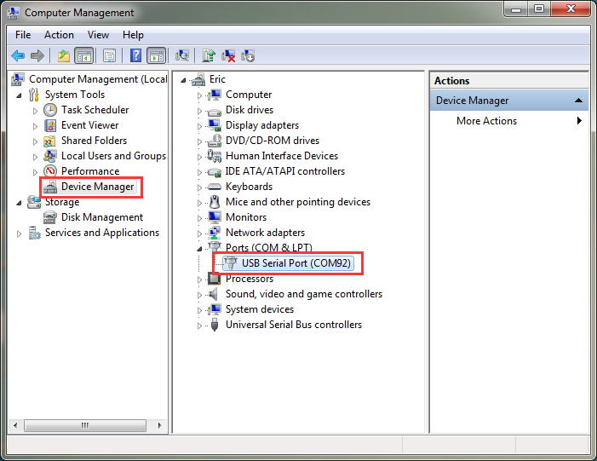

If the driver cannot be automatically installed, please download the FTDI or find it in the SD card and then manually install it.

1.2 EasyPrint 3D Installation and Configuration
EasyPrint 3D is a piece of 3D printing software, engineered for Geeetech products. In addition, it is also compatible with other printers.
Step1. Install EasyPrint 3D.
You can download it here: http://www.geeetech.net/firmware/EasyPrint.msi
Step2. After the installing is finished, find the icon EasyPrint 3D. Double click it to start the software.

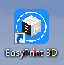

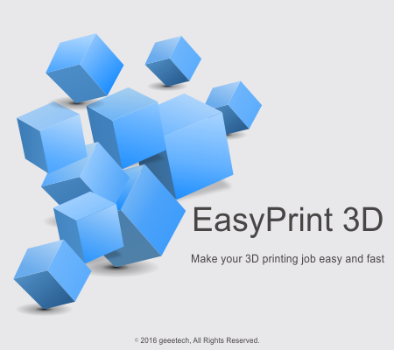

Then you can choose English in Config>Language.
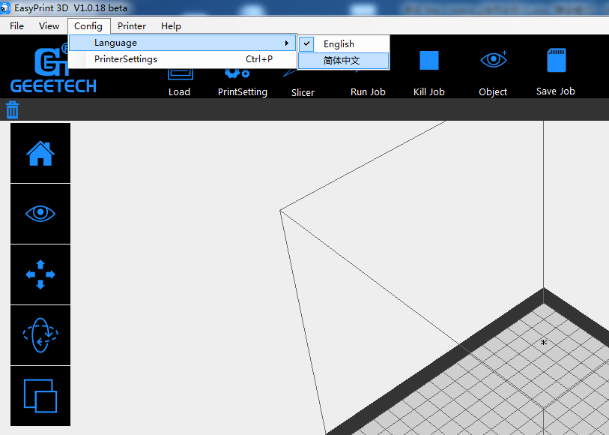
Step 4. Select the COM Port
Click the Printer menu, and then select the corresponding COM Port.
* The COM Port refers to the port that can be used for connecting the printer and your computer, identical to the USB serial in the device manager.
In case you could not find the COM Port, make sure that the power switch of your printer is turned on and the USB cable is well connected with the computer.
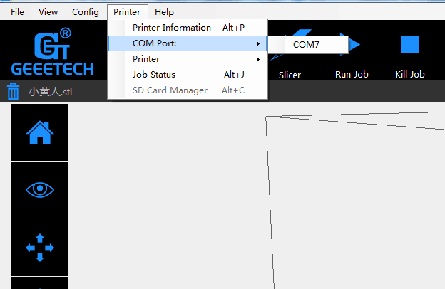

Step 5. Select the Printer
Click the Printer menu, and then choose the proper printer type: Pro W
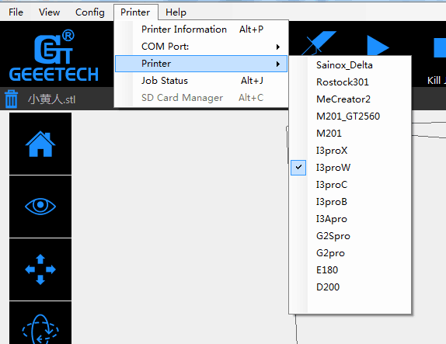

Click the Connect button on the top right. You could observe the real-time status of the printer on the bottom of the software interface.
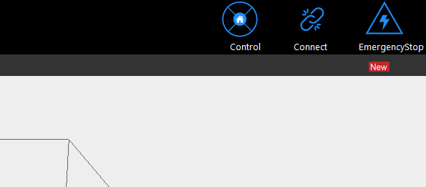

2. Hotbed Leveling
Before printing, we need to do hotbed leveling. Only after this step can the quality of printed parts get improved. Otherwise the un-leveling gap between the hotbed and extrusion head will affect the filament adhesion to the hotbed, which would cause poor print quality or even not printing.

Homing
Home the printer by clicking

- 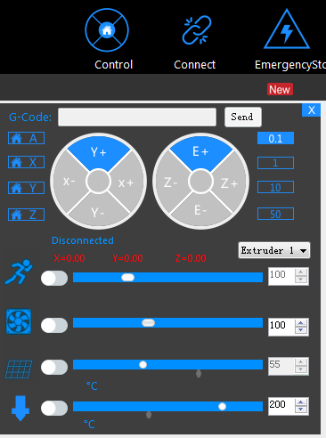

2.2 Coarse Tuning of distance between the nozzle and the hotbed
*If the nozzle is far from the surface of hotbed, loosen the M3x35mm screw to decrease the distance between the nozzle and the hotbed.
*If the nozzle is too close to the surface of hotbed, tighten the M3x35mm screw to increase the distance between the nozzle and the hotbed.
You may need to calibrate for many times at this step.
The recommended distance between the nozzle and the hotbed is 0.5-1mm.
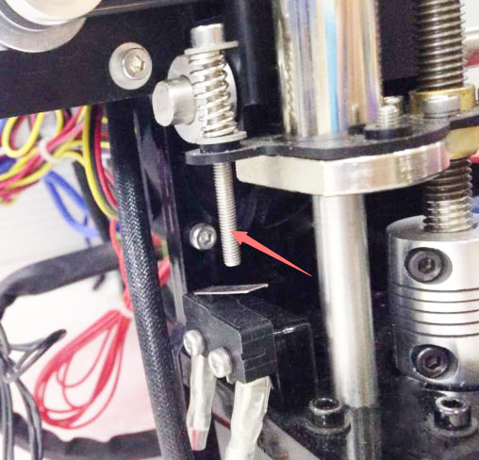

2.3 Fine Tuning
After the initial adjustment, home the printer. Disable the stepper motors via LCD control panel, manually move the extruder to the four corners of the hot bed and fine-tune the wing nut at each corner to level the distances between the extrusion head and four corners. During adjustment, you can put a piece of A4 paper (half fold it) between the nozzle and hotbed. If you can feel a bit friction pulling the paper back and forth, the distance is proper.

After finishing the adjustment of four corners, the entire leveling process is done. You can also move the extruder to the center of hotbed to verify leveling outcome.

3. Print Settings
EasyPrint 3D provides two print setting modes: quick mode and custom mode. The [quick] mode is designed for entry-level users, while the [custom] mode is tailored for expert user with finer printing parameters.

3.1 Quick mode
Choose [quick] tab. Here, we have prepared 3 printing quality settings for you.
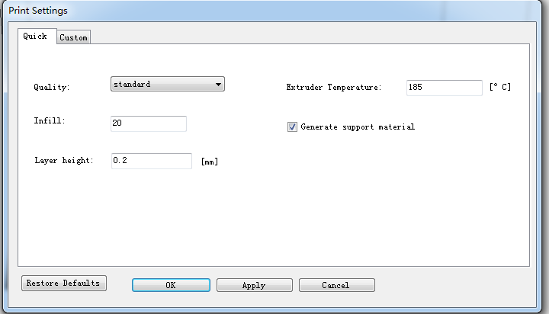

- Quality
Choose Low, Standard, or High quality to specify the surface quality of your 3D print.
• Objects sliced with the High quality profile will have finer layers and will print more slowly.
• Objects sliced with the Standard quality profile will be printed using the default settings.
• Objects sliced using the Low quality profile will be printed with thicker layers and will print faster.
- Infill: The density of the infilling structure.
- Extruder temperature: Different filament requires different temperature for extruders; please refer to the suggested temperature.
- Layer height: the thickness of each layer. You can leave it as default.
- Supports
Select this checkbox to have your object printed with support structures. EasyPrint 3D will automatically generate supports for any overhanging sections of your object. Supports will be easily removable once you remove your finished object from the build plate.
When you have finished the setting process, click [Apply]. The current settings will be used to slice your model next time you print or export a print file.

3.2 Custom mode
For advanced users who want to exert more sophisticated control over the whole printing process, EasyPrint 3D provides a series of parameters for you to engineer the printing configuration.

3.2.1 Create a new configuration/setting
To customize settings, you need to create a new setting first. Click the [create new conf.] tab and enter the name of new configuration in the textbox. Click [Ok].

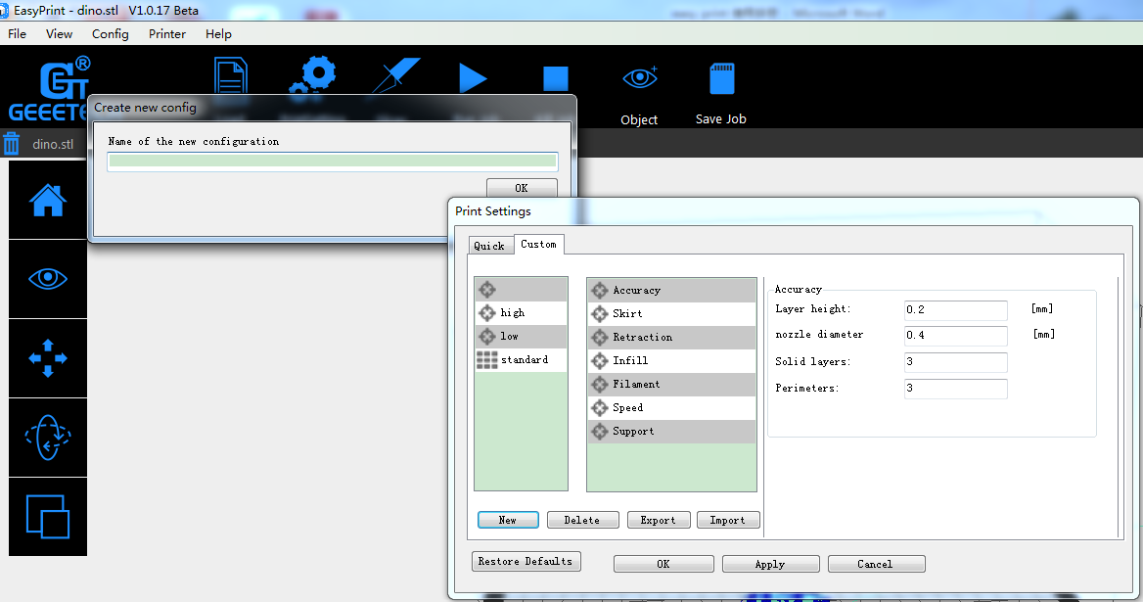

3.2.2 Print settings
Choose the [custom] tab to enjoy the sophisticated print settings.
- Accuracy：
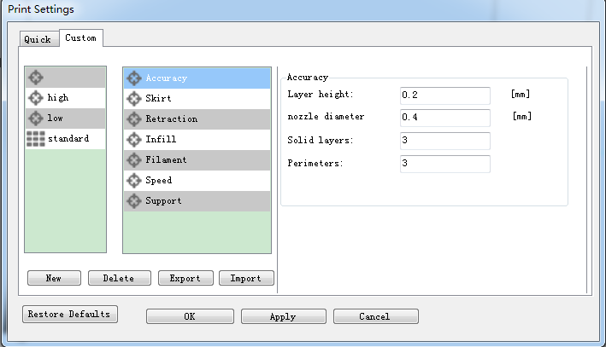
a. Layer Height:
The layer height is one of the most often adjusted settings. It is the thickness of one printed layer (in mm). With a thinner layer height you will increase the quality of the print, leading to a smoother surface and more detail visible in the Z-direction (height) of the model. On the other hand, by using thicker layers you can decrease the print time substantially.
b. Nozzle diameter: showing the diameter of the current nozzle.
c. Solid layers: The loops needed to finish just one layer.
d. Perimeter: The loops needed to finish printing one layer to make the printout more solid and the surface finish smoother.

- Skirt:
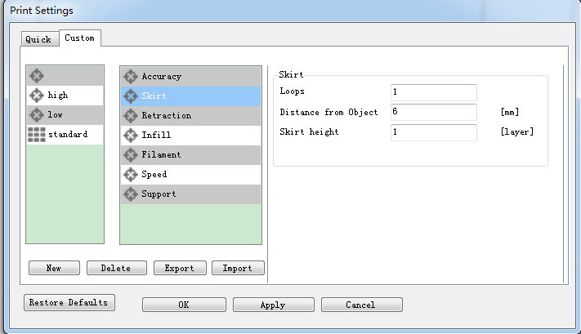
A skirt is a line printed around the object on the first layer, but not connected to the object. This helps prime the extrusion and can also be a good check for bed leveling before the print starts and it can ensure that the material is flowing smoothly from the extruder before it starts on the model proper.
a. Loops: The number of skirt lines printed around the model. One loop is usually sufficient.
b. Distance from object: The distance between the object and the skirt. The default of 6mm is usually sufficient.
c. Skirt height: The number of layers to lay down a skirt for. For ensuring the material is flowing smoothly, one layer is sufficient, however the skirt function can also be used to build walls around the object in case it should be protected from draughts.
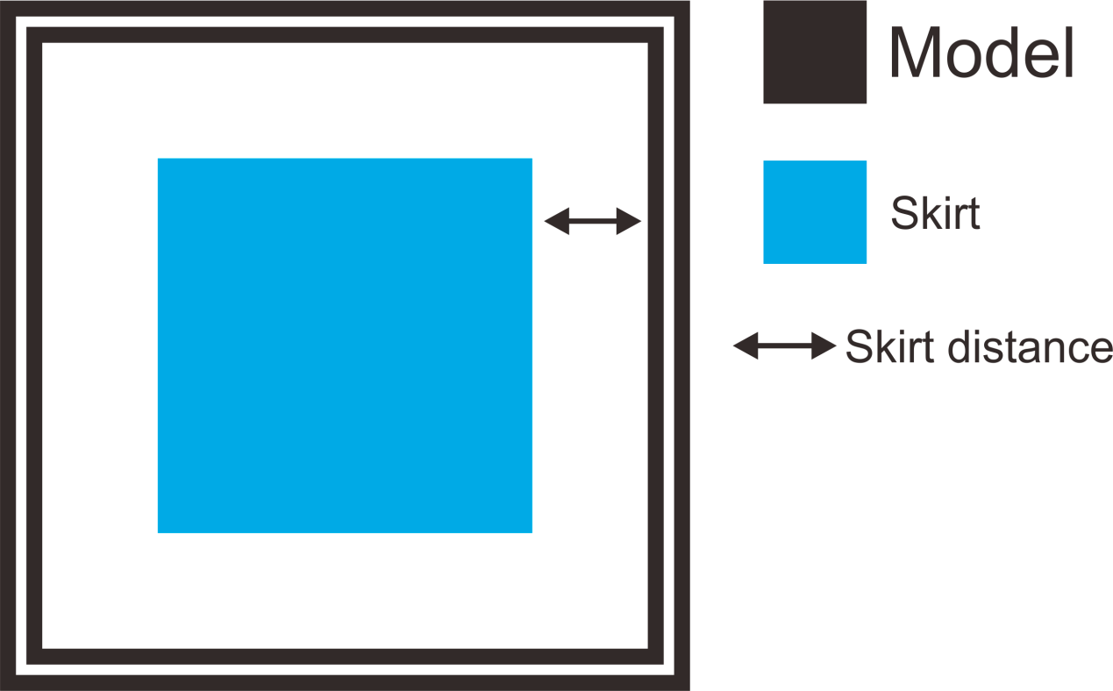

3) Retraction:
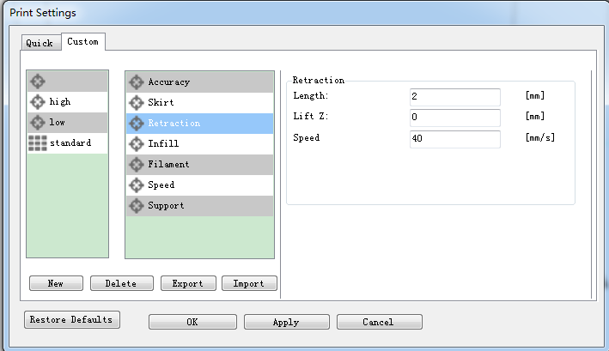
Retraction is used at the places in a print where the printer has to do a travel move between two printed parts. Without retraction extruded material will hang between the parts. This means that the filament is pulled back by the feeder, so that it doesn’t leak from the nozzle during the travel moves. By using retraction, “stringing” (thin threads of plastic in between the printed parts) is prevented, resulting in a much cleaner final model. You have to be careful with flexible materials or models that require a lot of retractions, as that might lead to grinding of the filament.
a. Length: The number of millimeters to retract. Note that the measurement is taken from the raw filament entering the extruder. A value of between 1 and 2mm is usually recommended. Bowden extruders may need up to 4 or 5mm due to the hysteresis introduced by the tube.
b. Lift Z: Raises the entire extruder on the Z axis by that many millimeters during each travel. This can be useful to ensure the nozzle will not catch on any already laid filament; however it is usually not necessary and will slow the print speed. A value of 0.1mm is usually sufficient.
c. Speed: The speed at which the extruder motor will pull back the filament. The value should be set to as quick as the extruder can handle without skipping steps, and it is worth experimenting with this value to find the quickest retraction possible.
- Infill:
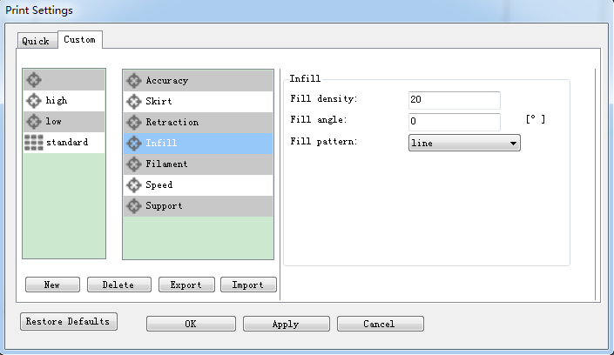
a. Fill Density: The infill density defines the amount of plastic used inside the print. A higher infill density means that there is more plastic on the inside of your print, leading to a stronger object. An infill density around 20% is used for models with a visual purpose; higher densities can be used for end-use parts.
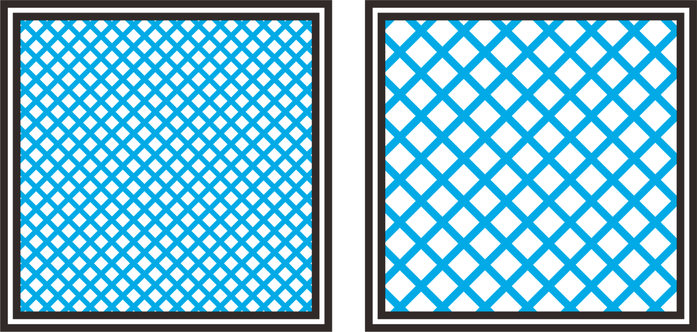
c. Fill angle: By default the infill pattern runs at 45° to the model to provide the best adhesion to wall structures. Infill extrusions that run adjacent to perimeters are liable to delaminate under stress. Some models may benefit from rotating the fill angle to ensure the optimal direction of the extrusion.
d. Fill Pattern: It is the pattern of filling shape which effects printing duration.
EasyPrint 3D offers seven infill patterns, including four regular flavors, and three more exotic ones. The numbers on the right of each figure are a rough estimate of material used and time taken for a simple 20mm cube model. Note that this is only indicative, as model complexity and other factors will affect time and material.
- Line ：
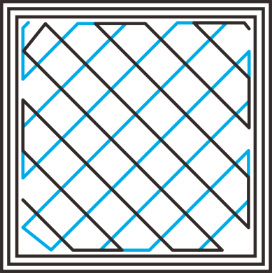 350.57mm/5m: 23s
2. Rectilinear
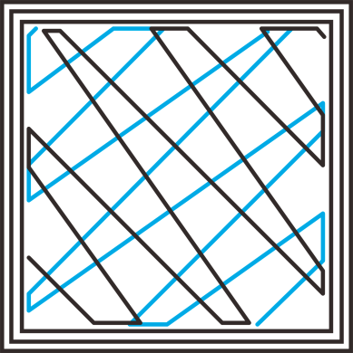 344.51mm/5m: 20s
3. Concentric
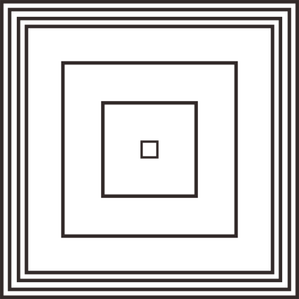 344.51mm/5m: 20s
4. Hilbert Curve
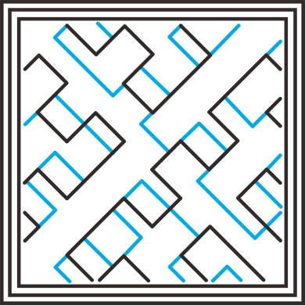 332.82mm /5m: 28s
5. Archimedean Chords
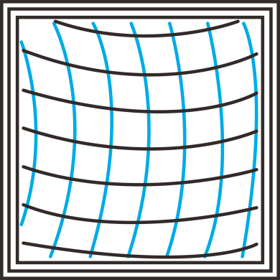 333.66mm /5m: 27 s

6. Octagram Spiral
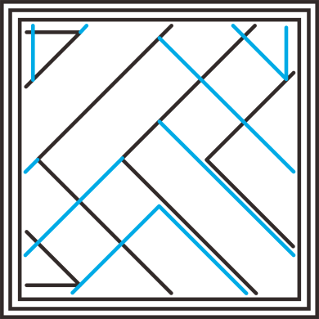 318.63mm/5m: 15 s
7. Honeycomb
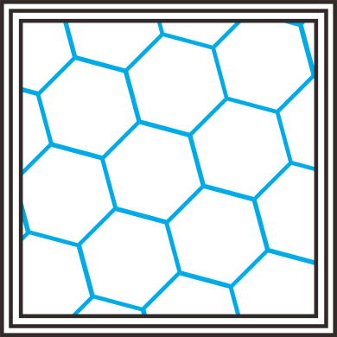 362.73mm /5m: 39s
- Filament:
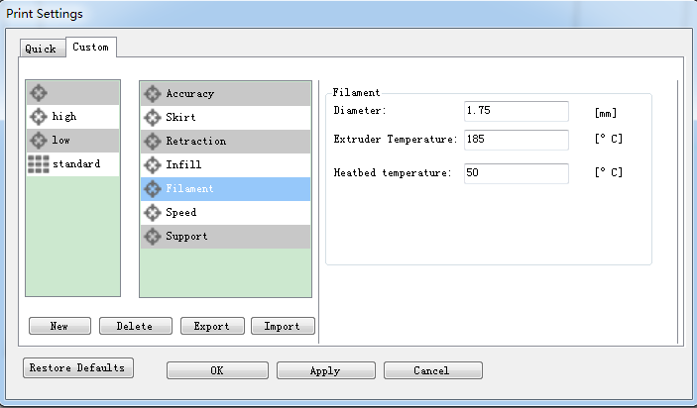
- Diameter:
In this field you can enter the diameter of the filament, so that EasyPrint 3D could calculate the extrusion rate correctly. The most commonly used filament diameters are 1.75mm and 3mm, but it might be necessary to change this setting when using filament from other suppliers.
- Extrusion temperature:
This is the temperature of the nozzle that is used during printing. The extrusion temperature can differ per material. PLA, for example, needs a printing temperature of approximately 180 -230 °C, while ABS needs a higher temperature of 210 - 250 °C to properly extrude the plastic.
- Hotbed temperature
For printers with a heated bed, the temperature of the heated bed can also be set here. We recommend using 60 °C for PLA and 90 °C for ABS to ensure that the plastic sticks well to the build plate.
- Speed:
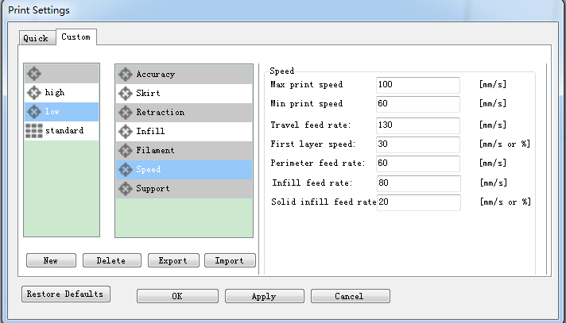
The print speed defines at which speed (in mm/s) the print head moves while printing. Based on this setting, EasyPrint 3D will also calculate how fast the filament must be extruded. A higher print speed will lead to a shorter print time. But keep in mind that increasing the print speed means that you might have to increase the temperature as well, to ensure the plastic is properly melted.
Although you can choose one overall print speed for the complete print, it’s also possible to use different print speeds for specific parts of the print:
- Max/Min print speed: This parameter defines the max/min speed [60-100mm/s] at which the printer runs.
- Travel feed rate: This is the speed at which the print head moves when it’s not extruding, that is, when the print head is moving from one point to another. A higher travel speed decreases the chance of filament leaking from the nozzle, producing a cleaner object. On the other hand, a very high speed means that the nozzle can hit an already printed part so fast that it might be damaged or deformed by the hot nozzle. This can be prevented by using lift z when retracting though.
- First layer speed: With this setting you can specifically change the speed for the first layer of the print. By default a low speed is used for the bottom layer, so that the material sticks well to the build plate on the first layer. As mentioned in the above section, the first layer is important to lay down correctly, and a slower pace helps enormously. Setting a value of 50%, or even less can really help.
- Perimeter feed rate: The speed at which the walls are printed. You can also set the speed for the outer and inner wall separately. Printing the outer wall a bit slower usually results in a better surface finish.
- Perimeter feed rate: The speed of printing the wall. You can set the speed of printing the exterior wall and the interior wall respectively. Usually, printing the exterior wall at a low speed will bring smooth surface for your final product.
- Infill feed rate: The speed at which the infill material is printed. Since (visual) quality of the infill is not important, you could use a higher speed for the infill. But keep in mind that this might affect the strength of your print.
- Solid infill speed: The speed at which the top layers are printed. A lower speed increases the reliability of closure of the top layers, especially on large area prints.

- Support:
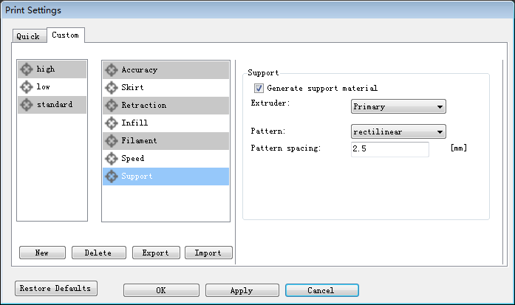
Generally, most 3D models will print with overhanging parts by up to a certain degree. The angle is determined by several factors, most notably layer height and extrusion width, and is usually around 45°. For models with larger overhangs, a support structure may have to be printed below it. This incurs the use of more material, longer print times, and post-printing clean-up.
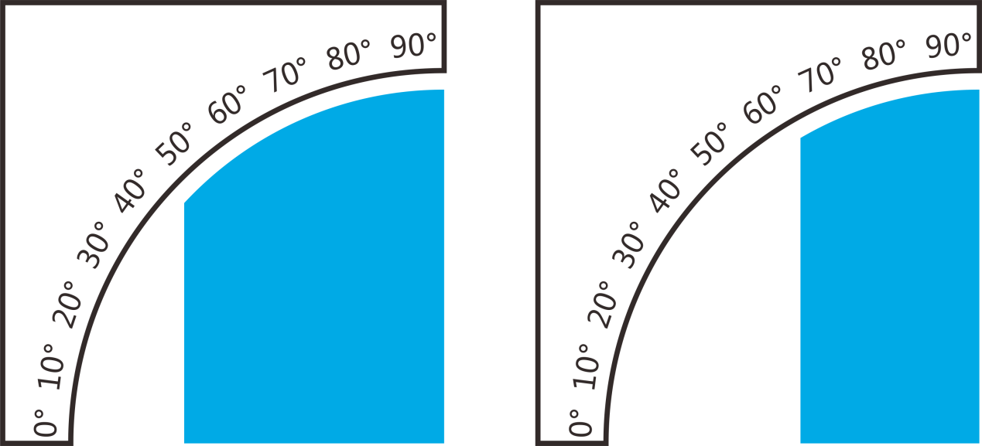
support (the blue part)
- Generate support material
Some models have overhanging parts, which means that parts of the model float mid-air when you would print the model. In this case you must use a support structure under the model to prevent the plastic from falling down. This can be achieved by generating support material. Select this checkbox to have your object printed with support structures.
- Extruder
If you are printing with dual extruder, you can select one of them to print the support material.
- Pattern
There are different patterns available for printing support structures, resulting in sturdiness or the easiness to remove the support. You can choose from the following patterns.
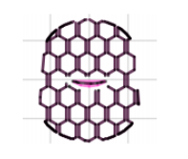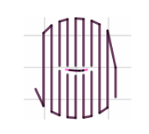
(1) Honeycomb (2) Rectilinear
d. Pattern Spacing
Pattern Spacing determines the distance between support lines, and is akin to infill density apart from being defined only in mm. The adjustment of this attribute by taking into account the width of the support extrusion and the amount of support material will adhere to the object.
Care should be taken to choose a support pattern which matches the model, where the support material attaches perpendicularly to the wall of the object, rather than in parallel, so it will be easy to remove. If the support structure does run along the length of a wall, the Pattern Angle option allows the direction of the support lines to be rotated.
Now all the parameters are set. Click [Apply] and [OK].

4. Begin Printing
So far, all the preparatory work is completed. The next step is to import the model file for slicing and printing. For 3D printer, the file format of the model is generally .stl file. We can download for free and print those models which are shared online, and you can also design your own creative objects for printing. Here we print a simple plate.

4.1 Load a Model File
Click [load] to load a.stl file from your computer, or you can drag it to the 3D view window. Now you would see your model at the center of a gray rectangle, the representation of your 3D printer’s build plate. Then you can use the tools on the left to edit your model.

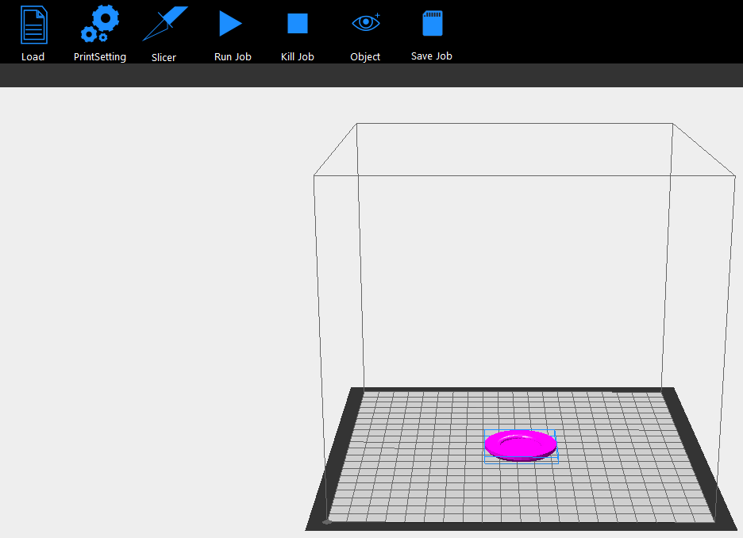

4.2 Print Setting
Making reference to the setting procedures in chapter 5, you can choose the simple [quick] mode or the sophisticated [custom] mode to customize your printing quality.

4.3 Slicing
After loading the model file and adjusting printing parameters, you can click the [slicer] icon to slice. It will take a while; the slicing time depends on the size of the model.

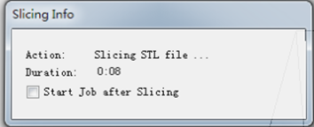
Upon slicing, you get the sliced .gcod file.
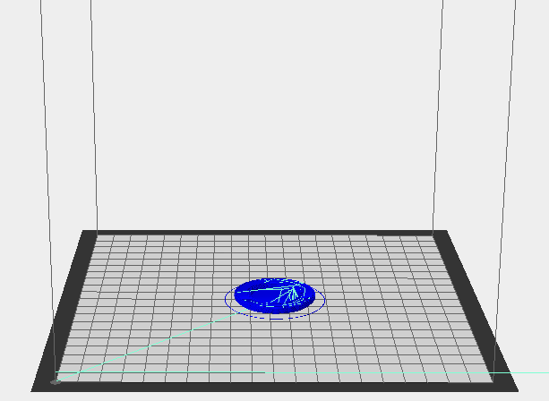

When you are ready to print your model, click [Run job] to embark on your printing journey.
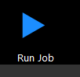

Stand-alone print with SD Card
If you want to print stand-alone , you can save the .gcode file in SD card for printing.
Note: The printer only recognizes .gcode file in the SD card, and the file can not be placed in any folder!
Steps are as follows:

4.4.1 Save Job
Click [Save job] for SD Print, and select the [save] button in the dialog box.
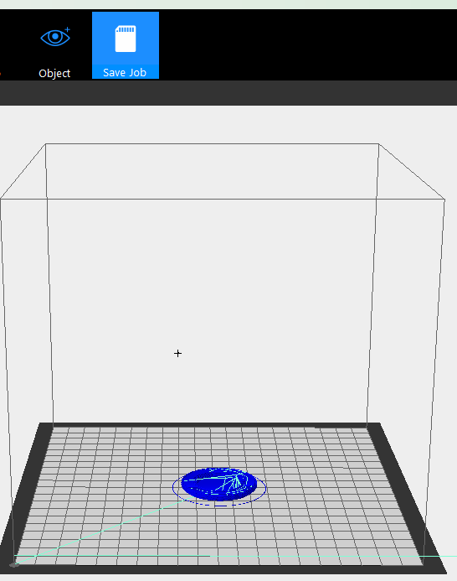

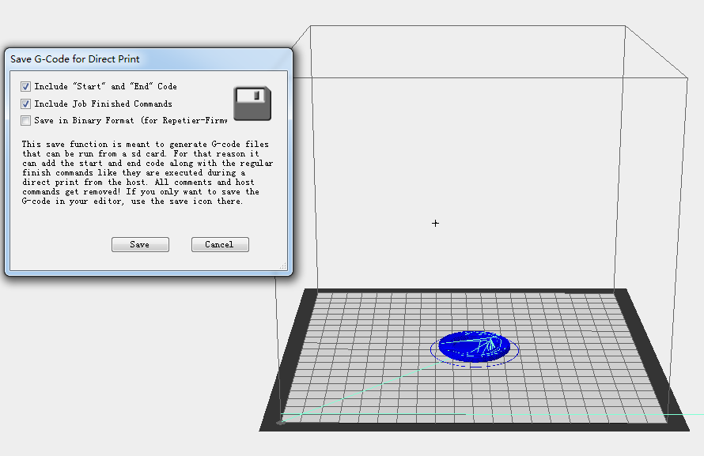

4.4.2 Print
Insert the SD card into the SD card slot at the back of the LCD control panel, and choose the corresponding .gcode to print.
Press the knob on LCD, rotate the knob to enter the main menu and choose Print from SD option.
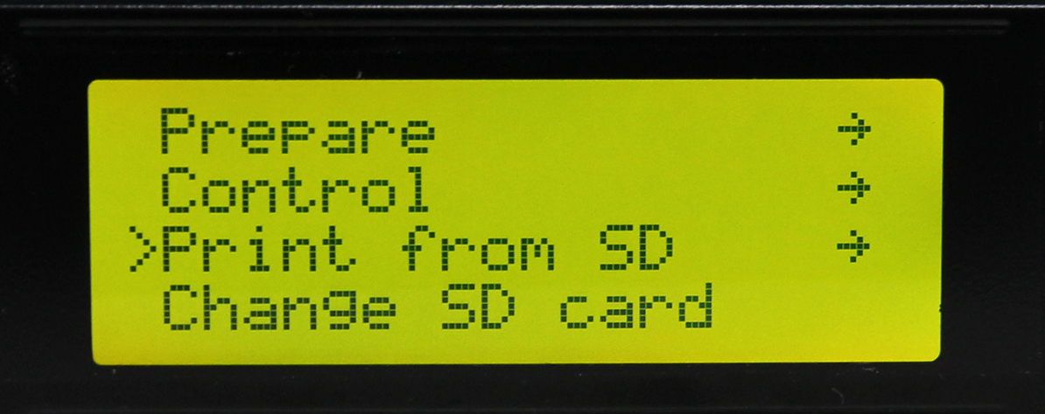
Choose corresponding .gcode file to begin printing.
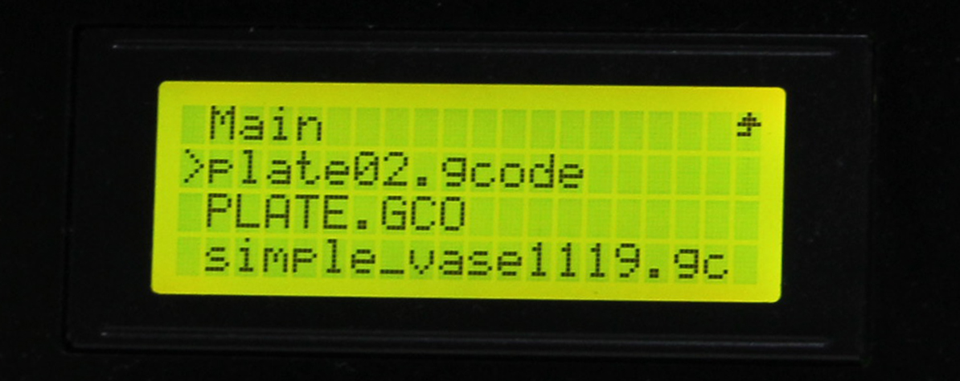

Heating
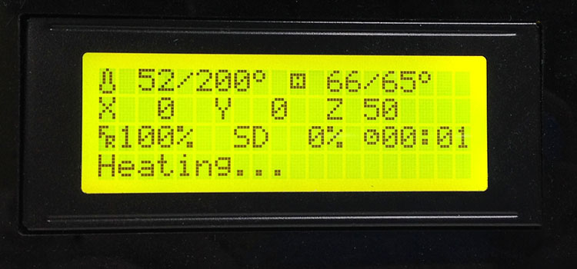

When heating is completed, it begins printing automatically.
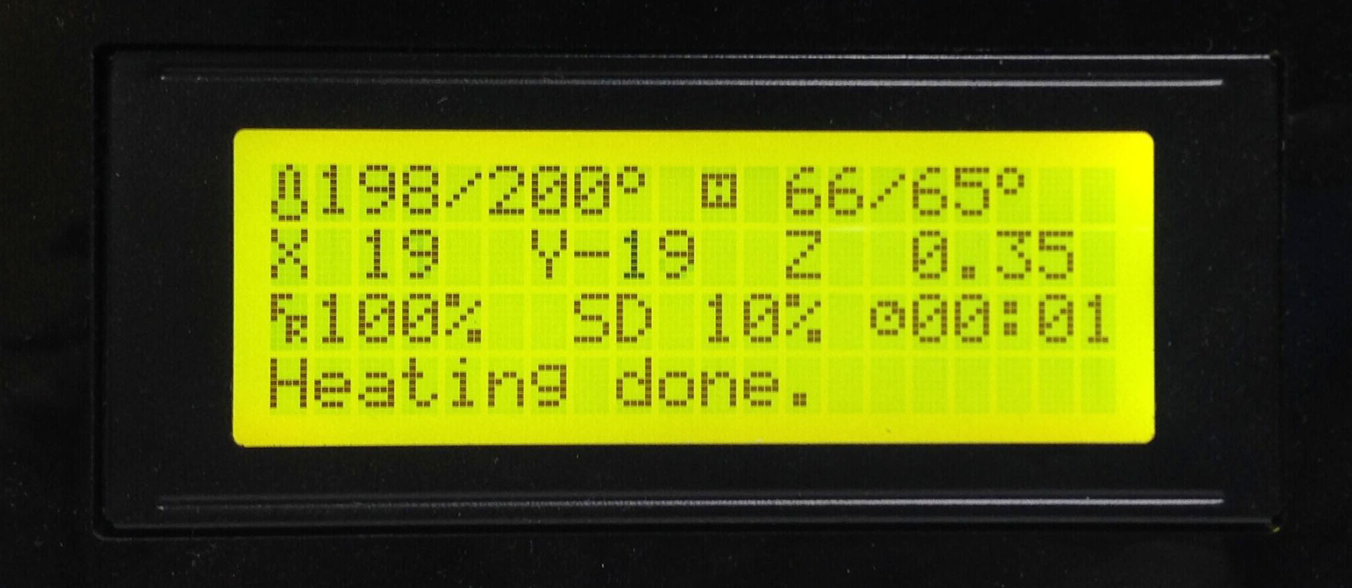

FAQ
If you encounter any problems during use, you can come to our forum: http://www.geeetech.com/forum/, and there are detailed solutions answer in the forum. Common problems are as follows:

5.1 How to upgrade firmware?
EasyPrint 3D provides all the users with online service of upgrading firmware to guarantee perfect printing performance.
The specific method is as follows:
- Connect your GEEETECH 3D printer to the computer with the USB cable.
- Turn the printer on.
- In EasyPrint 3D, choose the COM port and the printer type.
- Click ’help’> 'Update firmware'.
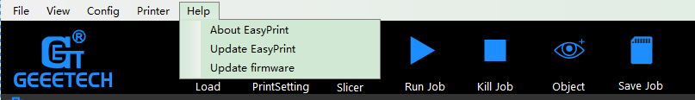
After clicking the [upgrade firmware] tab, a window will pop up with the information of printer type and port, the current firmware version installed, the available version and the update summary of the latest firmware. Take the printer D200 as an example:
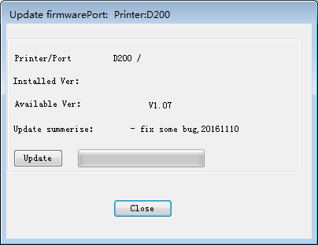
Click update and confirm updating, the progress bar will turn green, the firmware will be updated automatically. This process may take some time.
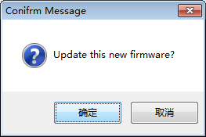
When the upload is complete the message ‘update sucess’ will be displayed.
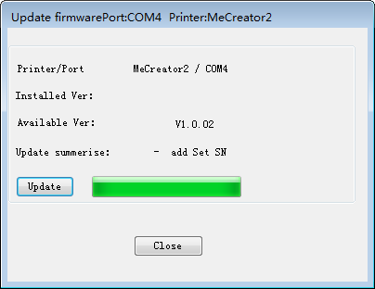
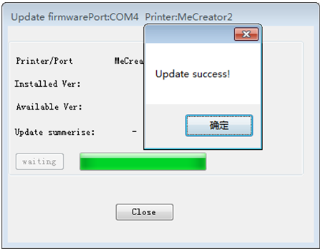
Click ‘ok’ and ‘Close’ on the windows to complete the firmware upgrade.

OR you can upgrade firmware by the following ways:
The way of uploading firmware, please refer to:
http://www.geeetech.com/forum/viewtopic.php?f=13&t=17181
Firmware download address, please refer to:
http://www.geeetech.com/forum/viewtopic.php?f=10&t=17046
Common parameters settings of firmware, please refer to:
http://www.geeetech.com/forum/viewtopic.php?f=13&t=17194

5.2 How to change the motor direction in firmware?
In the configuration.h tab of firmware, find the following codes. Change the true of corresponding axis into false or false into true, and save the firmware and burn into the printer. ( Because you don’t know the firmware which has been burned by mother board is true or false, it may be necessary to burn both of the two parameters.)
#define INVERT_X_DIR true
#define INVERT_Y_DIR false
#define INVERT_Z_DIR true
#define INVERT_E0_DIR false
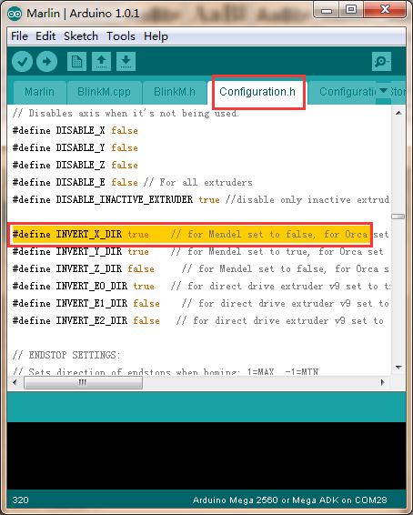

5.3 User manual of Repetier Host
For detailed user manual of Repetier Host, please refer to Wiki:
http://www.geeetech.com/wiki/index.php/Repetier-Host

5.4 Possible causes for motor’s non-action
http://www.geeetech.com/forum/viewtopic.php?f=13&t=17038

5.5 Extruder does not work normally
http://www.geeetech.com/forum/viewtopic.php?f=13&t=17097

5.6 The hotbed or extruder can not be heated
http://www.geeetech.com/forum/viewtopic.php?f=13&t=17039

5.7 LCD error： MAX/MIN TEMP error
http://www.geeetech.com/forum/viewtopic.php?f=13&t=17030

5.8 No information or displaying black square on LCD
http://www.geeetech.com/forum/viewtopic.php?f=13&t=17040

5.9 Time.h/endstop hit or other abnormalities
http://www.geeetech.com/forum/viewtopic.php?f=13&t=17037

